JSON WEB ENCRYPTION(JWE) JAVA Program
User Guide

Version: 1.0

Created by:
Name | Description | Date
Shruti Borkar | Initial draft | 11-11 -2024

Reviewer:

Name | Description | Date
Soumadeep Bagish | Initial draft | 11-11 -2024

Objective: This Java program provides encryption and decryption logic to partners to consume Bank’s provided services which are encrypted based on JSON Web Encryption (JWE).

Pre requisite: JAVA library: https://mvnrepository.com/artifact/com.nimbusds/nimbus-jose-jwt

Steps to follow:

Encryption:
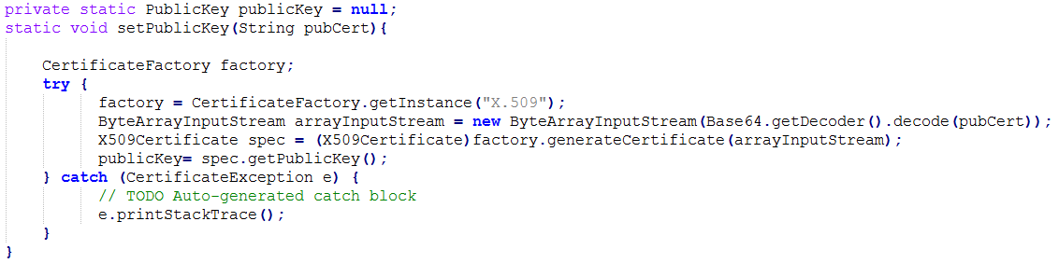
- Set public key using below function

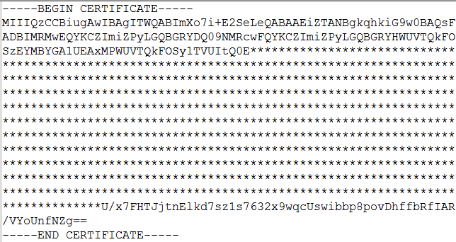
Sample public key:

- Encrypt the string data using following set of code, use public key which is generated from function setPublicKey. (mentioned above)
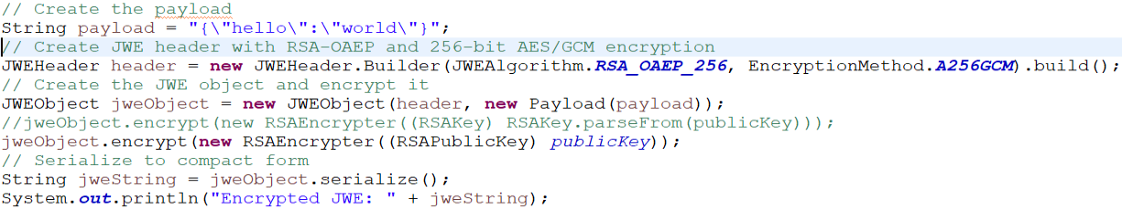

Sample input:
{"hello": "world"}

Sample output:
eyJlbmMiOiJBMjU2R0NNIiwiYWxnIjoiUlNBLU9BRVAtMjU2In0.W9CurprSnUqunnD4K7laNrAb1ZspFNNcwzH8axG0-eWn9bRJU_GUWB-bRpYwlz8MWWUlXQxg2Fx9fbSNHpwAun4R5CWnLIO-g6dmvD_yVPU4TqZY4yj06UfKZfCxCFc1_Ic94i_3q0XyEJ5NACo8H7JS2_5Ixe7IzyZ9syKxHqi0geQSACdVwT63Pd9-O7k22wh-mwbWJnRkb9LVG-UL_IeexTRS8kMSwgNtXKRdm6UEhtr0OtAyhCRk3isSaZZiMi1NdPjruqSWS1ZdHHB1MjgQOFsg_hO6tzU6rPxdnCkZAlfJnInoMj2ijJqRxUwBVnRbaQ6_8YCqwdh-p3Ftzg.rLpl1Q-4gC7ouQWb.K64IhzAJ9EJCspNO8RCqUS4.ZrKXOljF3YpAlzmaT3DGVQ

Decryption:
- Extract the key into pkcs8 format using below command
openssl pkcs8 -topk8 -inform PEM -outform PEM -in pkcs1.key -out pkcs8.key -nocrypt

Sample input key (pkcs1 format)
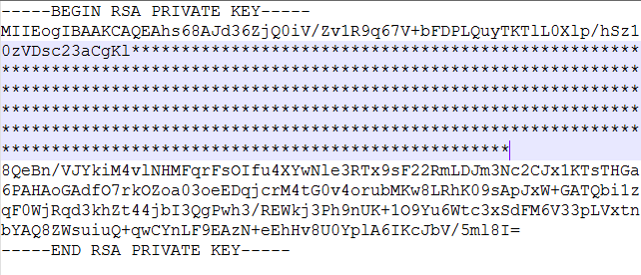
Sample Output key (pkcs8 format)
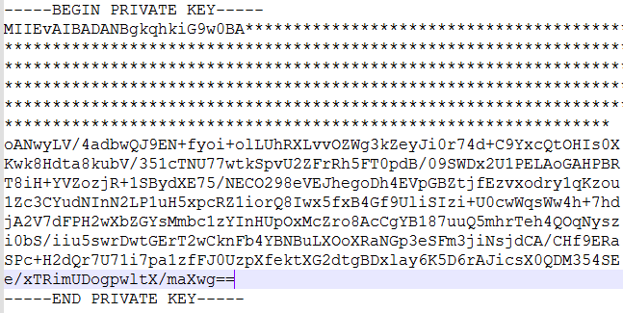

- Use below function to decode the private key. Use base64PrivateKey which is generated from command mentioned above.
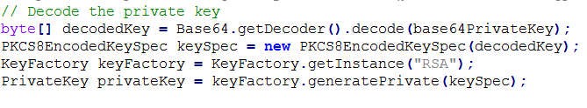
- Decrypt the string using following set of code. Use privateKey generated using function mentioned above.
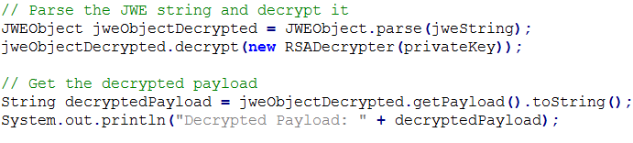
Sample input:
eyJlbmMiOiJBMjU2R0NNIiwiYWxnIjoiUlNBLU9BRVAtMjU2In0.W9CurprSnUqunnD4K7laNrAb1ZspFNNcwzH8axG0-eWn9bRJU_GUWB-bRpYwlz8MWWUlXQxg2Fx9fbSNHpwAun4R5CWnLIO-g6dmvD_yVPU4TqZY4yj06UfKZfCxCFc1_Ic94i_3q0XyEJ5NACo8H7JS2_5Ixe7IzyZ9syKxHqi0geQSACdVwT63Pd9-O7k22wh-mwbWJnRkb9LVG-UL_IeexTRS8kMSwgNtXKRdm6UEhtr0OtAyhCRk3isSaZZiMi1NdPjruqSWS1ZdHHB1MjgQOFsg_hO6tzU6rPxdnCkZAlfJnInoMj2ijJqRxUwBVnRbaQ6_8YCqwdh-p3Ftzg.rLpl1Q-4gC7ouQWb.K64IhzAJ9EJCspNO8RCqUS4.ZrKXOljF3YpAlzmaT3DGVQ

Sample output:
{
"hello": "world"
}

